|  |  |
| --- | --- |
| Assignment Date | 30th October 2022 |
| Student Name | M.S.Tamilarasan |
| Team ID | PNT2022TMID15244 |

**Problem:**

**PHARMA MONTHLY SALES DASHBOARD**

**Dataset:** [**Pharma Dataset/view**](https://drive.google.com/file/d/1t2PVp4xOzr94GFXRWz5WBOBv_nE4OGKu/view)

**Challenge:- Upload the dataset to Cognos Analytics, prepare the data, explore and Create Interactive Dashboard.**

Task 1:Sales By Customer. Task 2:Sales By Location.

Task 3:Sales By Sales Representative. Task 4: Received Inventory From Supplier

Task 5: Inventory Stock for Warehouse Locations Task 6: Sales Trend

Task 7:Monthly Sales

Task 8: Actual and Received Inventory by Month

1. **Uploading Dataset to IBM Cognos Analytics:**

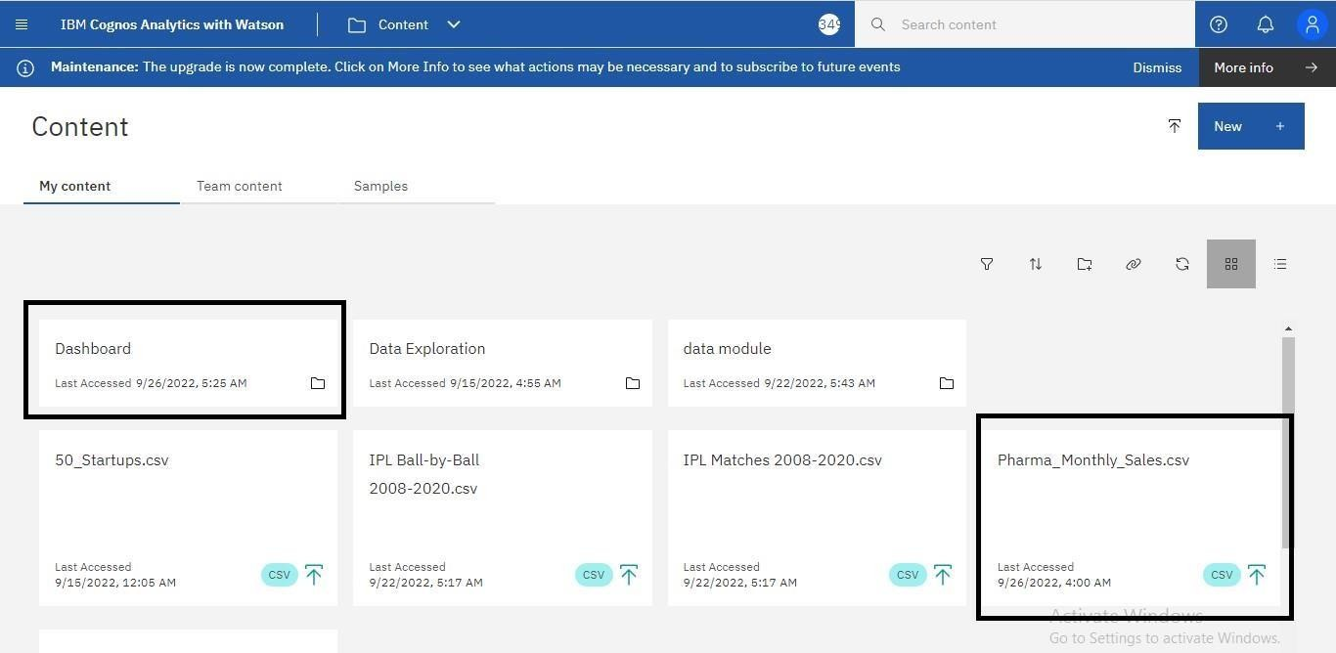

1. **Data Preparation:**

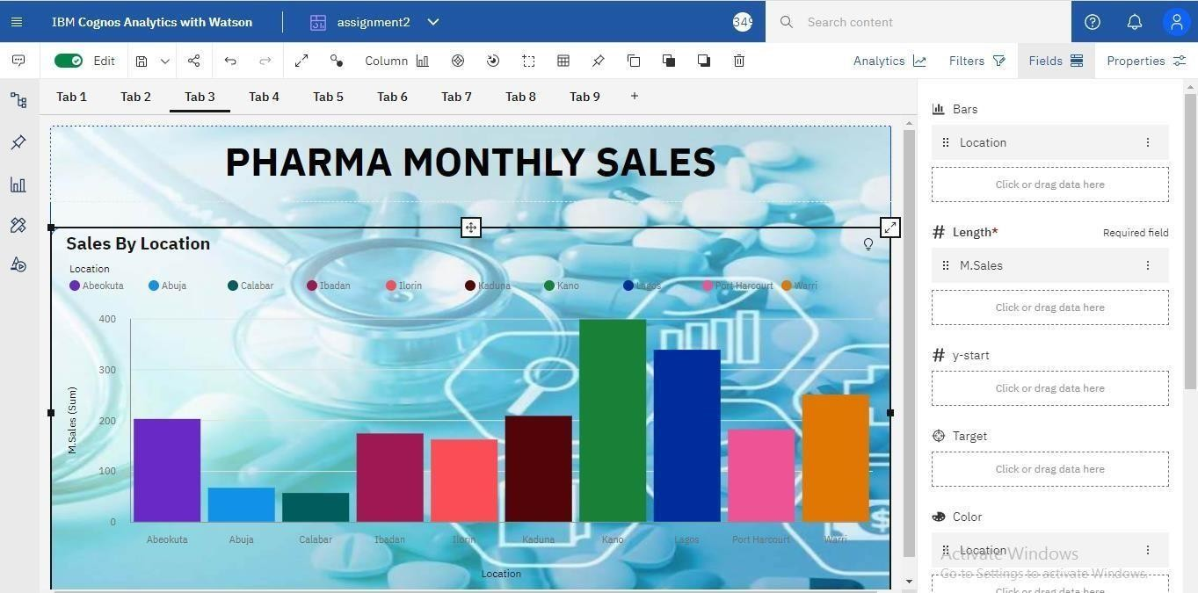

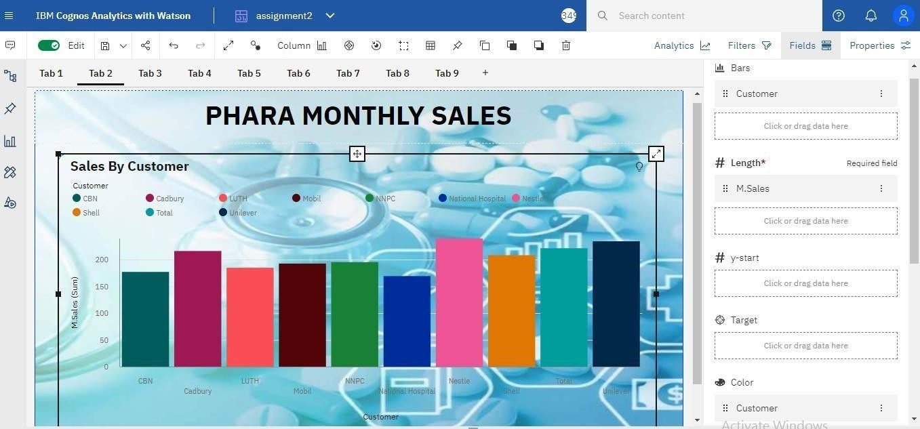

|  |
| --- |
| Sales By Customer |
| Sales By Location |

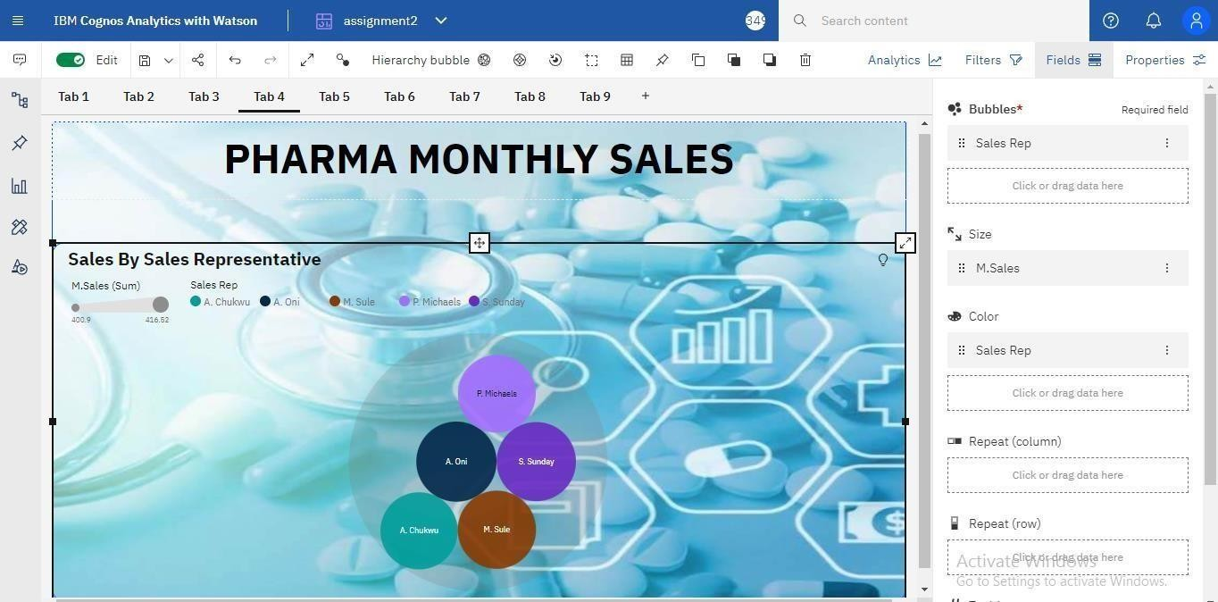



Sales By Sales Representative

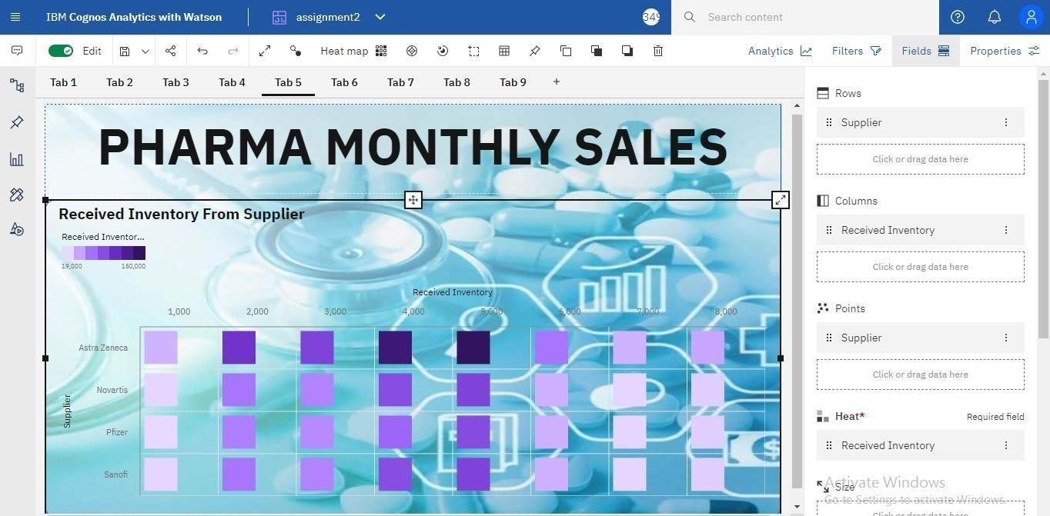



Received Inventory From Supplier

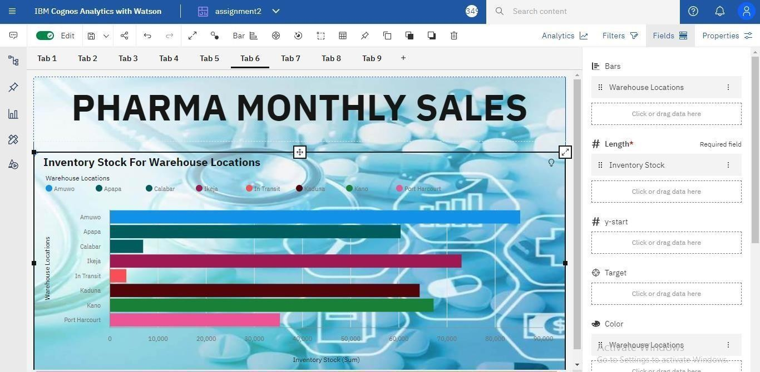

Inventory Stock For Warehouse Locations

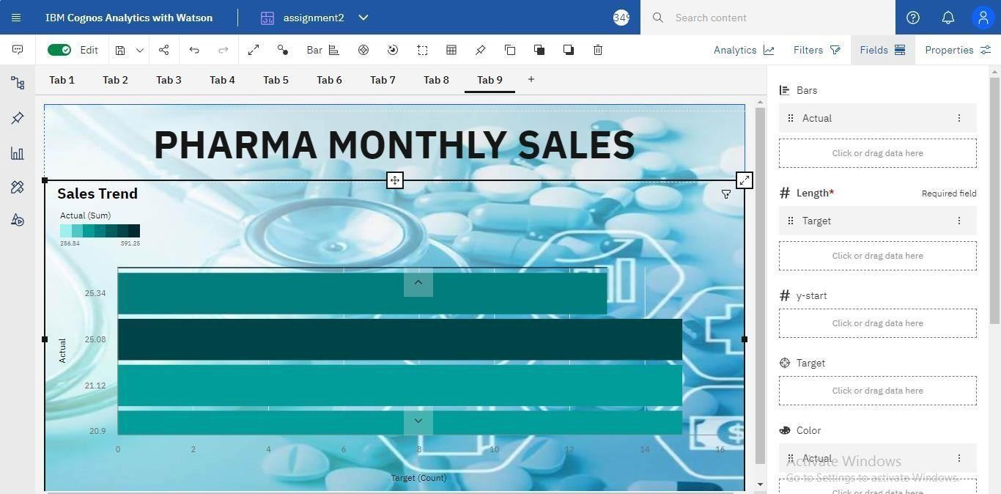



Sales Trend

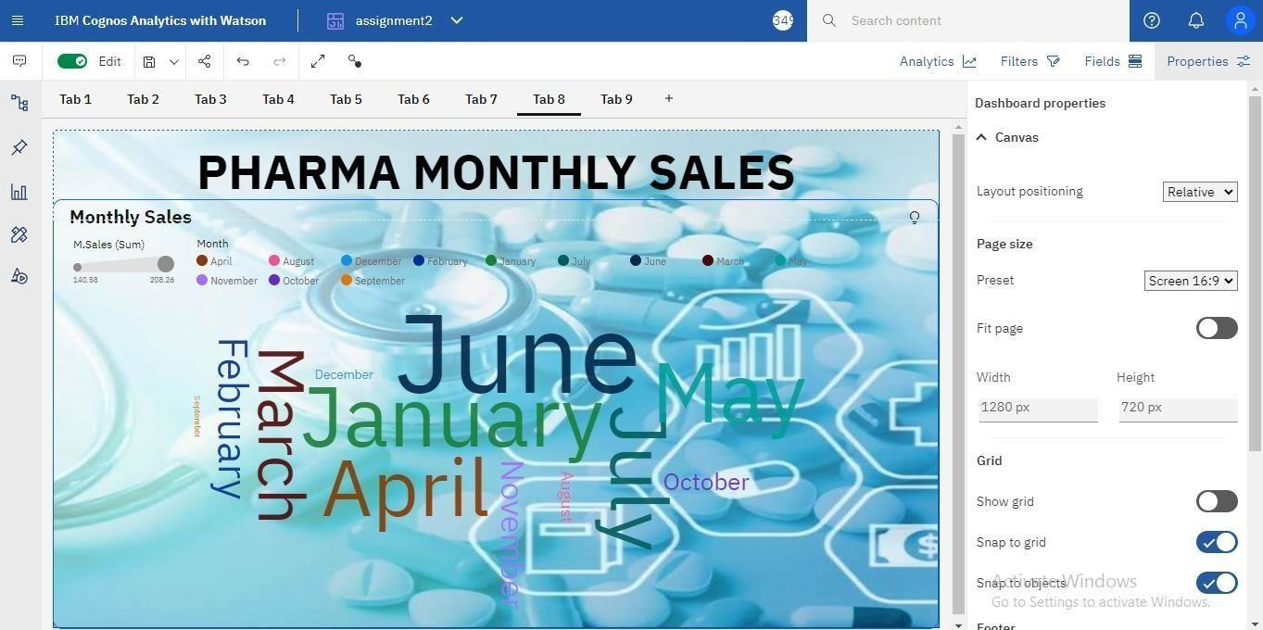



Monthly Sales

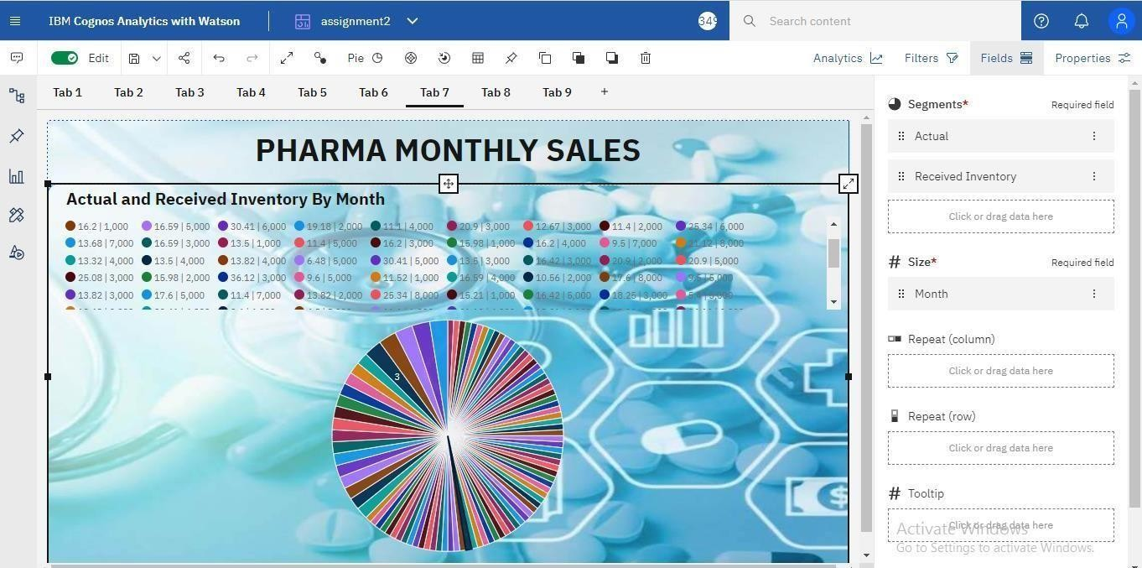



Actual And Received Inventory By Month